CHAPTER 1
INTRODUCTION
1.1 INTRODUCTION OF DOMAIN
Image processing is any form of signal processing method to convert an image into digital form and perform some operations on it, in order to get an enhanced image or to extract some useful information from it. It is a type of signal dispensation in which input is image, like video frame or photograph and output may be image or characteristics associated with that image. Usually Image Processing system includes treating images as two dimensional signals while applying already set signal processing methods to them. Image processing refers to digital image processing, but optical and analog image processing also are possible. The acquisition of images is referred to as imaging. Image processing basically includes the following three steps.
- Importing the image with optical scanner or by digital photography.
- Analyzing and manipulating the image which includes data compression and image enhancement and spotting patterns that are not to human eyes like satellite photographs.
- Output is the last stage in which result can be altered image or report that is based on image analysis.
Purpose of Image Processing
The purpose of image processing is divided into 5 groups. They are:
1. Visualization - Observe the objects that are not visible.
2. Image sharpening and restoration - To create a better image.
3. Image retrieval - Seek for the image of interest.
4. Measurement of pattern – Measures various objects in an image.
5. Image Recognition – Distinguish the objects in an image
Image
An image defined in the “real world” is considered to be a function of two real variables, for example, a(x,y) with a as the amplitude (e.g. brightness) of the image at the real coordinate position (x,y).
Modern digital technology has made it possible to manipulate multi-dimensional signals with systems that range from simple digital circuits to advanced parallel computers. The goal of this manipulation can be divided into three categories:
- Image processing (image in -> image out)
- Image Analysis (image in -> measurements out)
- Image Understanding (image in -> high-level description out)
An image may be considered to contain sub-images sometimes referred to as regions-of-interest, ROIs, or simply regions. This concept reflects the fact that images frequently contain collections of objects each of which can be the basis for a region. In a sophisticated image processing system it should be possible to apply specific image processing operations to selected regions. Thus one part of an image (region) might be processed to suppress motion blur while another part might be processed to improve colour rendition. Sequence of image processing:
Most usually, image processing systems require that the images be available in digitized form, that is, arrays of finite length binary words. For digitization, the given Image is sampled on a discrete grid and each sample or pixel is quantized using a finite number of bits. The digitized image is processed by a computer. To display a digital image, it is first converted into analog signal, which is scanned onto a display.
Closely related to image processing are computer graphics and computer vision. In computer graphics, images are manually made from physical models of objects, environments, and lighting, instead of being acquired (via imaging devices such as cameras) from natural scenes, as in most animated movies. Computer vision, on the other hand, is often considered high-level image processing out of which a machine/computer/software intends to decipher the physical contents of an image or a sequence of images (e.g., videos or 3D full-body magnetic resonance scans).
In modern sciences and technologies, images also gain much broader scopes due to the ever growing importance of scientific visualization. Examples include micro array data in genetic research, or real-time multi-asset portfolio trading in finance.
Before going to processing an image, it is converted into a digital form. Digitization includes sampling of image and quantization of sampled values. After converting the image into bit information, processing is performed. This processing technique may be Image enhancement, Image restoration, and Image compression.
Image Enhancement
It refers to accentuation, or sharpening, of image features such as boundaries, or contrast to make a graphic display more useful for display & analysis. This process does not increase the inherent information content in data. It includes gray level & contrast manipulation, noise reduction, edge crispening and sharpening, filtering, interpolation and magnification, pseudo colouring, and so on.
Image Restoration
It is concerned with filtering the observed image to minimize the effect of degradations. Effectiveness of image restoration depends on the extent and accuracy of the knowledge of degradation process as well as on filter design. Image restoration differs from image enhancement in that the latter is concerned with more extraction or accentuation of image features.
Image Compression
It is concerned with minimizing the number of bits required to represent an image. Application of compression are in broadcast TV, remote sensing via satellite, military communication via aircraft, radar, teleconferencing, facsimile transmission, for educational & business documents, medical images that arise in computer tomography, magnetic resonance imaging and digital radiology, motion, pictures, satellite images, weather maps, geological surveys and so on.
- Text compression – CCITT GROUP3 & GROUP4
- Still image compression – JPEG
- Video image compression – MPEG

Types
The two types of methods used for Image Processing are Analog and Digital Image Processing. Analog or visual techniques of image processing can be used for the hard copies like printouts and photographs. Image analysts use various fundamentals of interpretation while using these visual techniques. The image processing is not just confined to area that has to be studied but on knowledge of analyst. Association is another important tool in image processing through visual techniques. So analysts apply a combination of personal knowledge and collateral data to image processing.
Digital Processing techniques help in manipulation of the digital images by using computers. As raw data from imaging sensors from satellite platform contains deficiencies. To get over such flaws and to get originality of information, it has to undergo various phases of processing. The three general phases that all types of data have to undergo while using digital technique are Pre- processing, enhancement and display, information extraction.
1.2 PROJECT DESCRIPTION
Security is an important issue in information technology. It is an important issue which is ruling the internet world today. Study of mathematical techniques and its various aspects are main criteria in cryptography. Confidentiality, security, authentication are main issues in security. Visual cryptography and visual secret sharing are used to share a secret. Sensitive and important data can be shared secretly using visual secret sharing method. The secrets are encrypted and are shared to different participants. The participant’s shares are decrypted to reconstruct the secret. In (t, n) scheme t shares are needed to reconstruct the original secret. Single participant share is not valid, only when t shares are combined the original secret is reconstructed
The information communicated comes in numerous forms and is used in many applications. In a large number of these applications, it is desired that the communication to be done in secrete. Such secrete communication ranges from the obvious cases of bank transfers, corporate communications, and credit card purchases, on down to a large percentage of everyday email. Steganography is the ancient art of embedding a secret message into a seemingly harmless message. Most of the newer applications use steganography like a watermark, to protect a copy right on information. The forms of steganography vary, but unsurprisingly, innocuous spam messages are turning up more often containing embedded text. A new transform domain technique for embedding the secrete information in the integer wavelet transformed cover image is implemented here.
Cryptography is a technique to scramble a confidential message to make it unreadable for a third party. It is commonly used in the Internet communications today. Cryptography can hide the content of the message, but it can't hide its presence, i.e., the location of the secret message is obvious. This is the reason why an encrypted message can be targeted by the attackers. Watermarking is another information hiding technique which is used for hiding, actually embedding, some digital evidence, or symbol data, in the valuable digital data such as a photo picture, musical sound, digital movie, etc. The purpose of the watermarking is to protect copyright and/or ownership of the data. In this technique the robustness of the embedded evidence, that can be very small, is the most important. In watermarking the valuable information is the external information that is visible / audible.
Now days, various modes of communication like LAN, WAN and INTERNET are widely used for communicating information from one place to another around the globe. Such communication networks are open which any one can access easily. They are regularly monitored and an intercepted.
Steganography, from the Greek, means covered or secret writing, and is a long-practiced form of hiding information. Although related to cryptography, they are not the same. Steganography's intent is to hide the existence of the message, while cryptography scrambles a message so that it cannot be understood. More precisely, The goal of Steganography is to hide messages inside other harmless messages in a way that does not allow any enemy to even detect that there is a second secret message present.
Blakley and shamir developed (t, n) threshold scheme, where a dealer encrypts and divide the secret into n number of shadows. This scheme is proposed in the year 1979. The dealer then distributes the shadows to the authorized participants. Any t out of n, authorized participants can cooperate to reveal the secret data with their corresponding shadows. Visual secret sharing developed by shamir from the (t, n) – threshold concept. Secret image is encoded into random images named as shadows, during transmission the shadows are transmitted instead of secret. Wang and Chen et al explain the problems like pixel expansion, contrast, and meaninglessness. Since intruders will be attracted over meaningless images an approach called steganography is used to hide the shadows in to another image. This embedded image is called stego image. Since the stego image is meaningful, this hides the shadow from the intruders. Lin and Tsai and Wu, Y.S., Thien, C.C., Lin suggested a secret sharing method that produces shadows based on t-1 polynomial. These shadows are embedded within a cover image to hide the secret. owever the secret image reconstructed using the above secret sharing method will have distortions because of truncations of gray pixels values that are greater than 250. In medical and sensitive images, even small distortions are not tolerable. Thien and Lin, Chang Et Al. and Zhao Et Al overcome these drawbacks by using two pixels to represent the grey values that are greater than 250. This results in expansion of secret image and hence distorts the quality of the tego image. To increase the capacity of the embedded secret stream, in early 2009, embedded (t-3) secret digits into F(x), instead of embedding one secret pixel into the (t -1) degree polynomial F(x). Novel image secret sharing for color image is proposed in our paper which possesses reversible characteristics as. Authorized participants are allowed to reconstruct the secret and the original cover from the stego using the reversibility scheme. This reversible scheme can be used for medical image processing, artistic images and military images where the secret is retrieved without any distortion.

Steganography Techniques
Information hiding techniques are receiving much attention today. The main motivation for this is largely due to fear of encryption services getting outlawed, and copyright owners who want to track confidential and intellectual property copyright against unauthorized access and use in digital materials such as music, film, book and software through the use of digital watermarks.
There are many ways to hide information in digital images. We look at the following approaches:
- Least Significant Bit Insertion
- Masking And Filtering
- Algorithms And Transformations
1.3 PROBLEM STATEMENT
The problem in the hiding information or Steganography is the size of data that user want to embed inside the multimedia file, image is one of the multimedia file, the most commend method for hiding information in the image is LSB, LSB is efficient instead of that it’s not easy to analysis, however, it is not effective in term of the data hidden quantity, all researchers agreed the fact that the size of data hidden is a problem in that particular area, the other problem that faced there, in fact if we try to increase the quantity of data in the image there will be a suspect changes which become clear to human eyes, for instance, this research will face a challenge that high rate data hidden without affecting the images quality, there are many trends that needs to be fallowed, initially; how can the new algorithm increase the amount of data, then what is the feature in the new image, how can the new algorithm deal with, all this items will be discuss in-depth in this research by suggest an enhancement to the work of hiding information in the image using the human vision system.
As a summery, the main problems in the Steganography fallow as:
  - The size of data hidden
  - Quality of image
  - Algorithms that apply should also cover the gray level image
  - Level of data protecting
  - The level of suspecting
1.4 OBJECTIVE
Steganography includes a vast array of techniques for hiding messages in a variety of media. Among these methods are invisible inks, microdots, digital signatures, covert channels and spread-spectrum communications. A message is embedded in a cover media in an invisible manner so that one could not suspect about its existence. The main objective of the project is to provide security and different requirements mentioned.
Requirements
Different requirements depending on the purpose of Steganography:
- Capacity: it is an important factor in captioning applications, when a lot of information should be embedded into a cover image, what is usually related to the current picture. For example when transmitting medical images, the personal data, and the diagnosis could be embedded into the same picture.
- Imperceptibility: it is important when a secret communication occurs between two parties and the fact of a secret communication is kept to be secret.
- Robustness: watermarking, fingerprinting and all copyright protecting applications demand robust steganographic method, i.e. where the embedded information cannot be removed without serious degradation of the image.
Security
The security of our important information is based on the techniques of signal processing, cryptography, and Steganography. The security of information has been strengthened by applying scanning, coding, and encryption, cover processing and embedding techniques in the method. Reshaping step of the method provides robustness for detecting message correctly in such situation when stego image is distorted. The method developed is safe from various attacks. Simulation and steganalysis results shown in this paper shows that one will not be able to distinguish between cover and stego images.
Thus we conclude that the strength of security achieved is very high and unauthorized receiver will not be able to get back the original message using exhaustive without the knowledge of key parameters. Digital Steganography is interesting field and growing rapidly for information hiding in the area of information security.lt has a vital role in defense as well as civil applications. In future we will more of secure systems based on this technology. Several methods for hiding data in, images were described, with appropriate introductions to the environments of each medium, as well as the strengths and weaknesses of each method. The key algorithm for designing the Steganography system has been dealt. Most data-hiding systems take advantage of human perceptual weaknesses, but have weaknesses of their own. We conclude that for now, it seems that no system of data-hiding is totally immune to attack.
However, Steganography has its place in security. Though it cannot replace cryptography totally, it is intended to supplement it. Its application in watermarking and fingerprinting, for use in detection of unauthorized, illegally copied material, is continually being realized and developed.
Steganography is a technique to make confidential information imperceptible to human eyes by embedding it in some innocent looking "vessel" data (aka "carrier", "cover" or "dummy" data) such as a digital image or a speech sound. Steganalysis is another research topic about steganography. The objective of steganalysis is to find out a stego-file among the given files. It is a technique to detect a suspicious image/sound file that is embedded with crime-related information. So, it is a topic to make a "sniffer-dog program" to break steganography. However, it is very difficult to make such program that really works.
CHAPTER 2
LITERATURE REVIEW

2.1 Least significant bit in GIF [3]
Introduction
Palette based images, such as GIF images, are popular image file format commonly used on the Internet. GIF images are indexed images where the colors used in the image are stored in a palette or a color lookup table. GIF images can also be used for LSB steganography although extra care should be taken. The main issue with the palette based approach is that if one changes the least significant bit of a pixel, it could result in an entirely different color since the index to the color palette gets modified. One possible
Solution to this problem is to sort the palette so that the color differences between consecutive colors are minimized. The strong and weak points regarding embedding information in GIF images using LSB is that since GIF images only had a bit depth of 8, the total amount of information that could be embedded will be less. GIF images are vulnerable to statistical as well as visual attacks, since the palette processing which has to be done on the GIF image leaves a clear signature on the image. This approach was dependent on the file format as well as the image itself, since a wrong choice of image could results in the message being visible.
Disadvantage
- Secrecy of image no guaranteed
- The message being visible
2.2. Steganographic Method based on Difference Expansion
Technique [9]
Introduction
Difference Expansion (DE) is a simple and efficient reversible data-embedding method used for digital images. Here the redundancy in the digital content is explored to achieve reversibility. In this method, one bit can be embedded into two consecutive pixels. So the maximum embedding capacity will be 0.5 bpp. The main advantage of this technique was that it discovers extra storage space by exploring the redundancy in the image content. Both the payload capacity limits as well as the visual quality of embedded images of the DE method are the best along with a low computational complexity.
The difference expansion technique was later generalized so that n -1 bits can be embedded into n pixels, resulting the maximum embedding capacity (n -1)/n bpp. However, the difference expansion based reversible data hiding methods could not gain much Popularity as the method double the differences between pixels in successive iteration.
Disadvantage
- DE based technique had low payload capacity.
- Technique could not be used for applications demanding high visual quality.
- The distortions were larger and hence DE was vulnerable to statistical attacks.
2.3. Hiding Behind Corners [5]
Introduction
Certain digital techniques do not take into account the covers original information hereby they leave certain marks on the stego image. In Hiding Behind Corners (HBC), this was avoided by taking the covers original information. Two algorithms were used in HBC based on using image filters to determine the effective hiding places in an image. They were FilterFirst and BattleSteg. The strength of FilterFirst was that it eliminates the need to provide any additional information such as original image.
It was also very effective in hiding information. Whereas the weakness of FilterFirst was that it was not secure, as an attacker can repeat the filtering process. It could be also much easier to retrieve the hidden information once the stegoimage is identified. The strength of BattleSteg was that it requires a password to retrieve the message.
Disadvantage
- Hiding Behind Corners (HBC) approach effectively utilizes edge areas but embedding capacity is less.
- The absence of a random seed so it was impossible to know where to place the shots and also it was possible for BattleSteg to never have a hit.

2.4. Hiding Secret Message in Edges of the Image (RELSB) [8]
Introduction
Hiding Secret Message in Edges of the image introduced a new least significant bit embedding algorithm for hiding secret messages in non-adjacent pixel locations at the edges of images. Here the messages were hidden in regions which were least like their neighboring pixels i.e. regions that contain edges, corners, thin lines etc so that an attacker will have less suspicion of the presence of message bits in edges, because pixels in edges of an image appears to be much brighter or dimmer than their neighbors. Edges can be detected by edge detection filters such as a 3x3 window Laplacian edge detector.
One common disadvantage of LSB embedding was that it created an imbalance between the neighboring pixels. Here this imbalance was avoided by flipping the gray-scale values among 2i-1, 2i and 2i+1. The various strengths of this scheme were that an attacker will have less suspicion to the presence of message bits in edges because pixels in edges appear to be either much brighter or dimmer than their neighbors and it was also secure against blind steganalysis. It also limits the length of the secret message to be embedded.
Disadvantage
- The embedding capacity was relatively low
- It could not make full use of edges during embedding.
2.5. Adaptive Data Hiding in Edge Areas of Images with Spatial LSB Domain Systems (AE-LSB) [13]
Introduction
Here a new adaptive least-significant bit (LSB) steganographic method based on pixel-value differencing (PVD) was proposed. The difference value of two consecutive pixels estimates how many secret bits to be embedded into the two pixels. Pixels located in the edge areas were embedded with more secret bits than that located in smooth areas. The range of difference values were adaptively divided into lower level, middle level, and higher level. The readjusting phase ensures that the two consecutive pixels belong to the same level both before and after embedding. The range [0, 255] of difference values was divided into different levels. For extracting data exactly, the difference values before and after embedding must belong to the same level. This scheme provides more capacity and better quality than the PVD and was an improved version of PVD.
Disadvantage
- It was less tolerant to steganalysis.
2.6. Steganographic Method based on Pixel Value Differencing and Modulus Function [12]
Introduction
High Quality Steganographic method with PVD and Modulus function was an extension of PVD based approach. This technique first calculates the difference value between two consecutive pixels and then modulus operation was used to calculate their remainder. The secret data were embedded into the two pixels by modifying their remainder. The hiding capacity of the two consecutive pixels depends upon the difference value taken. Lesser the difference value smoother the area, so only less secret data could be embedded and vice versa. The strength of the scheme was that it could greatly reduce the visibility of the hidden data than the PVD method. Since the scheme used the remainder of the two consecutive pixels it was more flexible
Disadvantage
- Differences reveal the presence of a secret message.
- The modified pixels will be spread around the whole stego image and many smooth regions get contaminated.
2.7. Data Hiding Method Based On Interpolation Technique [6]
Introduction
Reversible data hiding method based on Interpolation Technique (IT) concealed data into interpolation errors. Instead of using the nearest neighbour interpolation technique, an image interpolation algorithm was used to obtain the interpolation errors. The reference pixels are adaptively selected in the cover image and pixels other than the reference pixels are interpolated. Interpolation errors are obtained by subtracting the interpolated pixels from the original image. Data bits were concealed by modifying the interpolation errors. Because reference pixel values were not changed in the embedding process, the same set of interpolated pixels could be obtained in the decoding process and thus, the embedded data bits could be extracted and the original image was restored.
In this technique, they reduced the number of reference pixels in smooth regions and increased the number of reference pixels in complex regions. But the distortions in the output image were much higher in histogram shifting method.
Disadvantage
- The number of reference pixels affects the payload and the stego image quality
- Interpolation Technique is less secure against image manipulations and steganalysis due to the presence of LSB replacement style asymmetry.
CHAPTER 3
SYSTEM ANALYSIS
3.1 EXISTING SYSTEM
The essence of invertible image sharing approaches is that the revealed content of the secret image must be lossless and the distorted stego images must be able to be reverted to the original cover image. In order to achieve these purposes, we first transform the secret pixels into the m-ary notational system and then calculate the information data used to reconstruct original pixels from camouflaged pixels such that the information data and transformed secret data are shared using the (t, n)-threshold sharing scheme. In this way, we can retrieve the lossless secret image and reverse the stego image to the original image. Based on our experiments, the shadows can be successfully camouflaged in the cover image, and the stego images have satisfactory quality. Moreover, our scheme allows for a large capacity of embedded secret data
3.2 PROPOSED SYSTEM
In this paper, the dealer embeds (t-1) secret digits in a polynomial instead of one secret pixel into the polynomial F(x). This process increases the capacity of the embedded data. A grayscale image is considered as a cover image. Using the help of prime number m, a value d will be calculated where d=p mod m.The output of invertible polynomial function will be encrypted with the help of the participant’s numerical key. Using the n participant’s key n shadows is generated. In order to preserve the pixel value of cover image quantization process is done. This quantization process helps to generate the cover without any loss of data. The n shadows are hidden into the cover image. The output of this process results in n stego images. The shadows are reconstructed from t stego images and the t participant’s key. Using these shadows the secret is reconstructed by Lagrange’s interpolation formula
3.3 ARCHITECTURE DIAGRAM

COLOUR IMAGE
CHANNEL (RGB) REP’N
SHADOW DERIVATION
QUANTIZATION
STEGO IMAGE GEN’N
STEGO IMAGE
TRANSMISSION
SHADOW RECONST’N
SECRET IMAGE

QUANTIZATION

COVER IMAGE

Fig 3.3.1: ARCHITECTURE DIAGRAM
3.4 DATA FLOW DIAGRAM
LEVEL 0

Colour Image

Colour Image

Encrypt/ Decrypt System

Fig 3.4.1: DATA FLOW DIAGRAM LEVEL 0

LEVEL 1
Colour Image
Channel (RGB) Representation
Quantization
Shadow Derivation
Stego Image Genration
Transmission
Stego Image

Fig 3.4.2: DATA FLOW DIAGRAM LEVEL 1
LEVEL 2
Stego Image
Colour Image
SHADOW Derivation
Quantization
Transmission
Stego Image Reconstruction

Secret Image Reconstruction

Fig 3.4.3: DATA FLOW DIAGRAM LEVEL 2
CHAPTER 4
SYSTEM REQUIREMENTS
4.1 HARDWARE REQUIREMENTS
- SYSTEM : PENTIUM IV 2.4 GHZ
- HARD DISK : 40 GB
- MONITOR : 15 VGA COLOUR
- RAM : 2 GB
4.2 SOFTWARE REQUIREMENTS
- O S : WINDOWS XP AND ABOVE
- APPLICATION : MATLAB
4.3 SOFTWARE DESCRIPTION
MATLAB
MATLAB (matrix laboratory) is a numerical computing environment and fitsth-generation programming language. Developed by MathWorks, MATLAB allows matrix manipulations, plotting of functions and data, implementation of algorithms, creation of user interfaces, and interfacing with programs written in other languages, including C, C++, Java, and Fortran.
MATLAB has a wide range of applications, including signal and image processing, communications, control design, test and measurement, financial modeling and analysis, and computational biology.

Syntax
The MATLAB application is built around the MATLAB language. The simplest way to execute MATLAB code is to type it in the Command Window, which is one of the elements of the MATLAB Desktop. When code is entered in the Command Window, MATLAB can be used as an interactive mathematical shell. Sequences of commands can be saved in a text file, typically using the MATLAB Editor, as a script or encapsulated into a function, extending the commands available.

Variables
Variables are defined as the assignment operator, =. It is a dynamically typed language because variables can be assigned without declaring their type, except if they are to be treated as symbolic objects and that their type can change. Values can come from constants, from computation involving values of other variables, or from the output of a function. For example:

Semicolons

Like many other languages, where the semicolon is used to terminate commands in MATLAB.

Structures
MATLAB supports structure data types. Since all variables in MATLAB are arrays, a more adequate name is "structure array", where each element of the array has the same field names. In addition, MATLAB supports dynamic field names (field look-ups by name, field manipulations etc). Unfortunately, MATLAB JIT does not support MATLAB structures; therefore just a simple bundling of various variables into a structure will come at a cost.

Function Handles
MATLAB supports elements of lambda-calculus by introducing function handles, or function references, which are implemented either in .m files or anonymous/nested functions.

Secondary Programming
MATLAB also carries secondary programming which incorporates the MATLAB standard code into a more user friendly way to represent a function or system.

Classes
MATLAB supports value classes and reference classes, depending if the class has handle as super-class (for reference classes) or not (for value classes).Depending if a class is declared as value or reference, method call behavior is different. For example, a call to a method object.method(); Can alter any variables of object variable only for reference classes.
Matlab Features
- Simple programming environment including control structures like loops and selections.
- Linear algebraic system solvers for vectors, matrices and functionality like computing products and inverses, scaling, summing, multiplications, factorizations, and so on.
- Simple graphic interface for visualization and simulation. Open component system based on toolboxes which can be created, modified, customized and shared by the users.
- Ability to zip and unzip files and folders in the Current Folder browser to simplify sharing of files
- New visual cues in the Current Folder browser to show directories on the MATLAB path
- Enhanced tab completion in the MATLAB Editor with support for local variables, sub functions, and nested functions
- Expanded access in the plot selector to plots from the Curve Fitting, Filter Design, Image Processing, and Signal Processing Toolboxes
- Enhanced File and Folder Comparison Tool, highlighting changes within lines in file comparisons, and sorting results by name, type, size, or timestamp in folder comparisons Performance and Large Data Set Handling
- Multithreaded computation support for long vector fft, conv2, integer conversion, and integer arithmetic function.
CHAPTER 5
SYSTEM DESIGN AND IMPLEMENTATION
5.1 SYSTEM DESIGN
These are the steps followed in image hiding while transmission and de noising after receiving:
- Get a cover image (publicly accessible material)
- Take the information to be hidden (message or image)
- Combine cover image with the information to be hidden
- While transmission it will be corrupted by noise
- Use any of the filtering methods
- Here filter is employed in order to remove the noise
- During extraction a password check is provided
- If password is matched then extraction of hidden information.
Survey of Methods, Experiments
The Embedding Process
Steganography embeds a secret message in a cover message, this process is usually parameterized by a stego-key, and the detection or reading of embedded information is possible only having this key. Fig.5.1.1 shows this process.
COVER IMAGE

STEGO SYSTEM ENCODER
STEGO SYSTEM DECODER

SECRET IMAGE
ESTIMATION OF SECRET MESSAGE
KEY
ORIGINAL COVER
COMMUNICATION CHANNEL

Fig 5.1.1: BLOCK DIAGRAM

5.2 LIST OF MODULES
The overall design of the system consists of 7 modules. Modules are:
- Channel (RGB) Representation
- Shadow Derivation
- Quantization Process
- Stego Image Generation
- Shadow Reconstruction
- Secret Image Reconstruction
- Cover Image Reconstruction
5.3 MODULES DESCRIPTION
5.3.1Channel (RGB) Representation
Color images are used as secret and as cover image. In color image each pixel is in the form of 3 channels red, green and blue. The pixel value of each channel is between 0-255.
5.3.2 Shadow Derivation
Secret sharing is a process of shadow generation. The secret color image pixels are converted into m-ary notational system with the help of the prime number m that is nothing but modulo operation of each pixel of secret color image. Let c1, c2, ct-1, d are co-efficient of invertible polynomial function F(x), p be the pixel value of cover color image. The output of m-ary notational system will be c1, c2……ct-1 digits. With the help of the prime number, d will be calculated for every pixel of each channel of cover color image, where d=p mod m. The invertible polynomial function is framed for Red, Green and Blue channel. The t-1 digits of red channel of secret color image and d of red channel of cover color image are the inputs of invertible polynomial F(x) = c1+c2x1+c3x2…+ct-1xt-2+dxt-1 mod m. Likewise F(x) will be generated for green and blue channels. The output of invertible polynomial function will be encrypted with the help of the participant’s numerical key. Each participant generates their shadows with their appropriate numerical key value. Fig. 1 shows the overall functionalities like shadow derivation, quantization, and stego image generation, cover and secret image reconstruction.
5.3.3 Quantization Process
Quantization process Q= (p/m)*m is done to preserve the cover image pixel value in order to retain the actual quality of cover image during reconstruction. Quantized pixel value is calculated with the help of two operations division and multiplication. Divide the cover image pixel by the prime 46 ICRTIT-2012 number m and take the floor value, perform multiplication by prime number on the floor value which gives the quantized value of cover image pixel.
5.3.4 Stego Image Generation
The cover image is used the hide the generated shadow images. By embedding the pixels of shadow image into cover image to get the stego images. The quantization value got from cover image is added to the pixel from shadow image to get the stego image.
5.3.5 Shadow Reconstruction
Each authorized participant will have a stego image and a key. Let sp be the stego image pixel value and y be the pixel value of shadow. With the help of prime number m, the shadows will be reconstructed where y = sp mod m. Likewise n shadows are reconstructed from n stego images. Shadows can be reconstructed from the stego images.
5.3.6 Secret Image Reconstruction
Secrets can be reconstructed only with minimum of t shadows, less than t is of no use. The Lagrange’s formula is formed by using participant’s numerical key and shadow value. The Lagrange’s formula is give below. In this F(x) is Lagrange’s interpolation equation, yj is shadow value and lj is calculated using participant’s numerical key. The original Lagrange’s interpolation equation is generated using formulas 1 and 2. The t-1 digits are converted to decimal value which results in the secret pixel value.
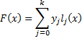 ..... (1)
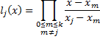 ..... (2)
5.3.7 Cover Image Reconstruction
Quantization operation Q= (sp/m)*m will be used to get back the color cover image without loss. Quantization operation is performed on the stego image, which will generate a quantized value. This quantized value is added with the last digit of Lagrange’s interpolation equation, the result of which reconstructs the cover image pixel
5.4 PERFORMANCE EVALUATION
In this Section, the performance and the simulation of the proposed scheme are explained; Six 256 X 256 color test images are taken as cover image. The experimental platform was programmed in Matlab version 7.9.
Peak to Signal Noise Ratio
The distortions present in the stego image are calculated using Peak to Signal Noise Ratio (PSNR).
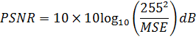
MSEcolor - Mean Square Error between the original cover color image and the stego color image.
For a cover image of size H x W, the MSEcolor is given as below,
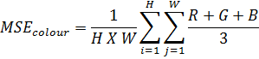
Where R, G, B are calculated as
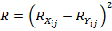
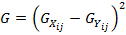
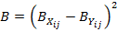
- Rxij and Ryij - Pixel values of the Red component in the original cover color image and the stego color image, respectively
- Gxij and Gyij - Pixel values of the Green Component in the original cover color image and the stego color image, respectively
- Bxij and Byij - Pixel values of the Blue component in the original cover color image and the stego color image, respectively.
A higher PSNR value means that the quality of the stego color image is similar to that of original color cover image. PSNR value less than 35 dB means that some of the important signal characteristics are lost. PSNR value less than 30 dB is an unacceptable quality. Good quality is implied by PSNR value greater than 35 dB
Table 5.4.1 represents the qualities of various stego images along with different test images using (3, n) threshold sharing scheme. Table 5.4.2 represents the PSNR values of Lena cover image under different prime number (m). Table 5.4.3 shows comparison of existing and proposed work.

Test Images | PSNR(dB)
Test Images | Stego Image 1 | Stego Image 2 | Stego Image 3
Zelda | 41.9751 | 41.5670 | 41.7876
Lena | 41.8735 | 41.6580 | 41.9831
Mandrill | 41.9586 | 41.4148 | 41.6506
Peppers | 41.4721 | 41.2956 | 41.1476
Tiffany | 41.9395 | 41.4091 | 41.6438
Splash | 41.6721 | 41.5689 | 41.4679
Table 5.4.1: COMPARISON WITH VARIOUS IMAGES
Prime Number(m) | PSNR(dB) (Lena)
3 | 47.8601
5 | 45.1602
7 | 41.8735
11 | 38.2424
13 | 36.6608
17 | 34.2382
19 | 33.4348
23 | 31.8863
29 | 30.8001
Table 5.4.2: COMPARISON WITH VARIOUS PRIME NUMERS

Other Methods | Drawbacks | Advancement of  Proposed Paper
LSB Substitution | Large cover image  needed, not bother  about the cover image  quality | Same size of cover  image is enough,  Cover image quality  is maintained by  Quantization  process
Small shadow  technique(compression) | Lossy is possible | Lossy is not  possible
(2,n) Secret Sharing | More Security is  needed | It follows (t, n)  threshold Sharing  Scheme. No use of  t-1 shadows.
(n, n) Secret Sharing | All shadows should  combine to retrieve  the secret
Table 5.4.3: COMPARISON WITH OTHER METHODS
CHAPTER 6
CONCLUSION
6.1 CONCLUSION
The reconstructed shadows are meaningless and the distortions are large. The proposed reversible image sharing approach for color image reveals the secret image without loss and preserves the cover image. The generated shadows are meaningful with better PSNR value compared with the previous methods. Based on (t, n) threshold scheme, any t authorized recipients can recover the secret by using the reversible process.
The methodology can be further enhanced for video and can be used for embedding text. One could redesign the system with more discriminative features. Plan to cover more image types and further improve the performance
APPENDIX A
SOURCE CODE
clc;
clear all;
close all;
nMod = 7 ;
%% cover image
[FileName,PathName] = uigetfile('*.jpg','Select the Cover Image');
file = fullfile(PathName,FileName);
disp(['User selected : ', file]);
cover = imresize(imread(file),[128 128]);
cover = double(cover);
if ndims(cover) ~= 3
msgbox('The cover image must be colour');
break;
end
figure;
subplot(1,2,1);
imshow(uint8(cover),[]);
title('Cover image');
%% secret image
[FileName,PathName] = uigetfile('*.jpg','Select the Secret Image');
file = fullfile(PathName,FileName);
disp(['User selected : ', file]);
secret = imresize(imread(file),[128 128]);
if ndims(secret) ~= 3
msgbox('The cover image must be colour');
break;
end
subplot(1,2,2);
imshow(uint8(secret),[]);
title('Secret Image');
%% Stegnography
% Quantification of secret image by a factor 45
[nRow, nColumn] = size(cover);
secret = double(secret)/45;
stegImg1 = zeros(size(cover));
stegImg2 = zeros(size(cover));
stegImg3 = zeros(size(cover));
shadowImg1 = zeros(size(cover));
shadowImg2 = zeros(size(cover));
shadowImg3 = zeros(size(cover));
encrykey = input('Please Enter an Encryption Key Between 0 - 255:\n');
if encrykey < 0 || encrykey > 255
error('Invalid Key enter');
end
encrykey = uint8(encrykey);
for k=1:3
m = mod(cover(:,:,k), nMod);
quantification = floor(cover(:,:,k)/nMod)*nMod;
[R C] = size(cover(:,:,k));
for i = 1:R
for j = 1:C
shadowImg1(i,j,k) = mod(m(i,j)*1,nMod);
shadowImg2(i,j,k) = mod(m(i,j)*2,nMod);
shadowImg3(i,j,k) = mod(m(i,j)*3,nMod);
stegImg1(i,j,k) = quantification(i,j)+ mod(m(i,j)*1 + secret(i,j,k),nMod);
stegImg2(i,j,k) = quantification(i,j)+mod(m(i,j)*2+ secret(i,j,k),nMod);
stegImg3(i,j,k) = quantification(i,j)+mod(m(i,j)*3+ secret(i,j,k),nMod);
end
end
end
figure;
subplot(1,3,1)
imshow(uint8(shadowImg1),[]);
title('Shadow Image 1');
subplot(1,3,2);
imshow(uint8(shadowImg2),[]);
title('Shadow Image 2');
subplot(1,3,3);
imshow(uint8(shadowImg3),[]);
title('Shadow Image 3');
figure;
subplot(1,3,1)
imshow(uint8(stegImg1),[]);
title('Stegno Image 1');
subplot(1,3,2);
imshow(uint8(stegImg2),[]);
title('Stegno Image 2');
subplot(1,3,3);
imshow(uint8(stegImg3),[]);
title('Stegno Image 3');
%%
decrykey = input('Please Enter an Decryption Key:\n');
if encrykey == decrykey
%Reverse secret image
revsecret = zeros(size(secret));
for k=1:3
mod1 = mod(stegImg1(:,:,k), nMod);
mod2 = mod(stegImg2(:,:,k), nMod);
mod3 = mod(stegImg3(:,:,k), nMod);
for e = 1:R
for f = 1:C
if mod2(e, f) < mod1(e, f) || mod2(e, f) == 0
mod2(e, f) = mod2(e, f)+nMod;
end
end
end
a1 = mod2 - mod1;
temp = mod1 - a1;
for e = 1:R
for f = 1:C
if temp(e,f) < 0
temp(e,f) = temp(e,f) + nMod;
end
end
end
revsecret(:,:,k) = temp*45 ; % dequantification
end
figure;
subplot(1,2,1);
imshow(uint8(revsecret),[]);
title('Reconstructed Secret Image');
%% Cover image reconstruction
dequantification = zeros(size(cover));
for k=1:3
dequantification1 = floor(stegImg1(:,:,k)/nMod)*nMod;
dequantification2 = floor(stegImg2(:,:,k)/nMod)*nMod;
dequantification3 = floor(stegImg3(:,:,k)/nMod)*nMod;
dequantification(:,:,k) = floor((dequantification1+dequantification2+dequantification3)/3);
end
subplot(1,2,2);
imshow(uint8(dequantification),[]);
title('Reconstructed Cover Image');
%% PSNR FOR STEGNO IMAGE
Q = 255;
MSE = sum(sum((stegImg1-cover).^2))/nRow / nColumn ;
PSNR=10*log10(Q*Q/MSE);
fprintf('The stegImg1PSNR performance is %.2f dB\n',sum(PSNR)/3);
MSE = sum(sum((stegImg2-cover).^2))/nRow / nColumn ;
PSNR=10*log10(Q*Q/MSE);
fprintf('The stegImg2PSNR performance is %.2f dB\n',sum(PSNR)/3);
MSE = sum(sum((stegImg3-cover).^2))/nRow / nColumn ;
PSNR=10*log10(Q*Q/MSE);
fprintf('The stegImg3PSNR performance is %.2f dB\n',sum(PSNR)/3);
else
msgbox('You have enter the invalid key');
end
APPENDIX B
SCREENSHOTS
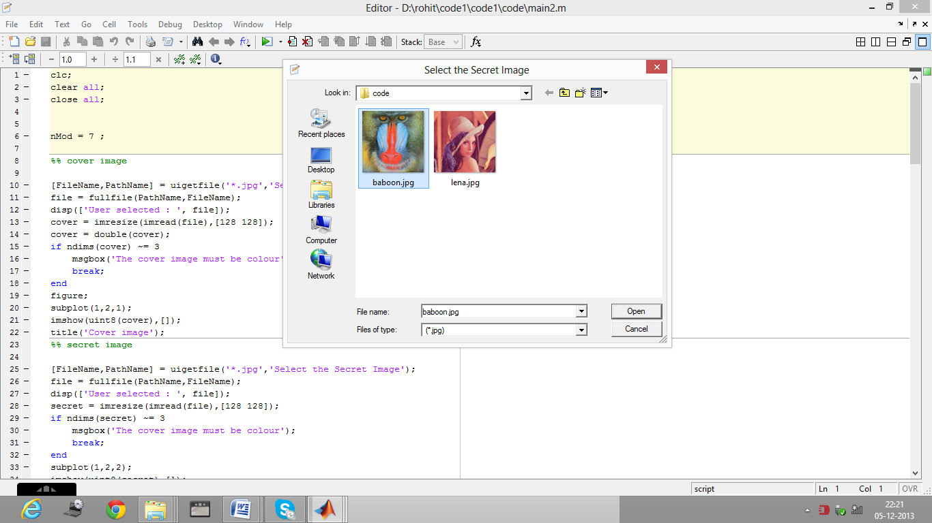
Fig B.1: SELECTING INUPTS
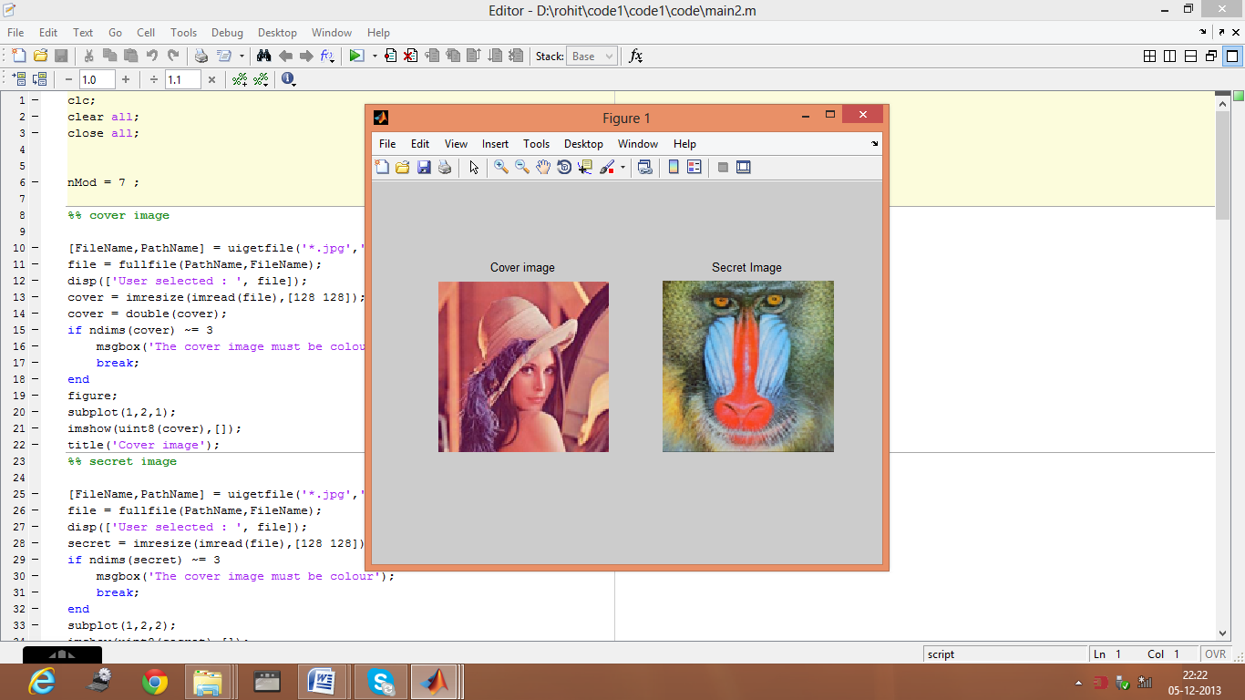
Fig B.2 COVER & SECRET IMAGE
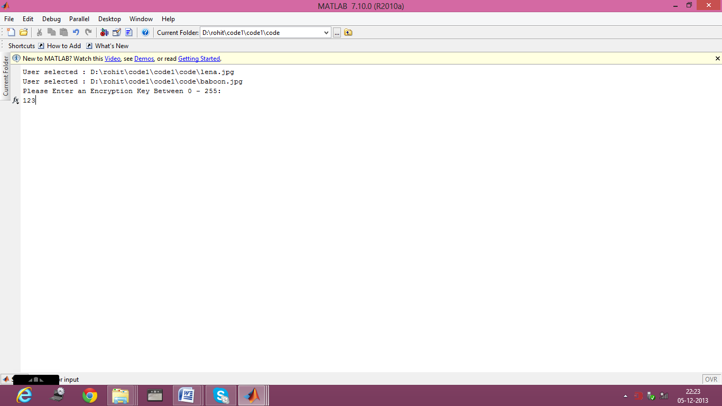
Fig B.3: INUPT ENCRYPTION KEY
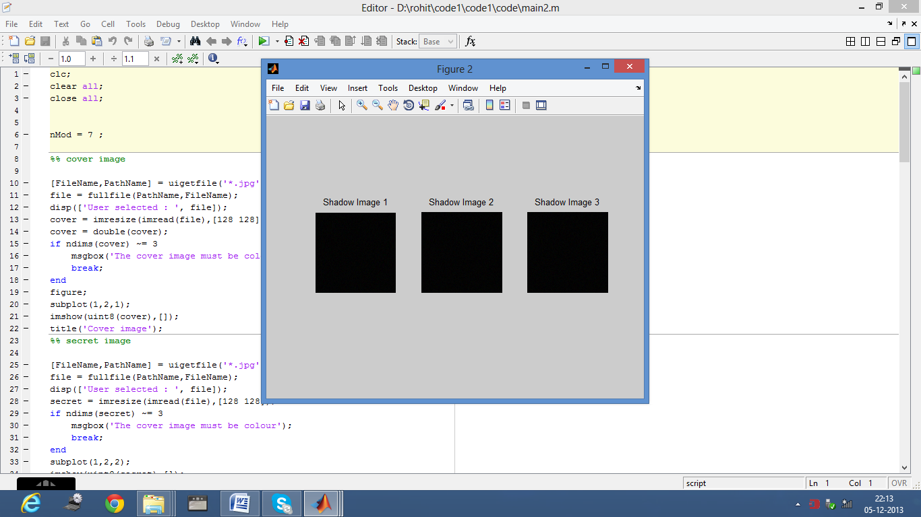
Fig B.4: SHADOW IMAGES
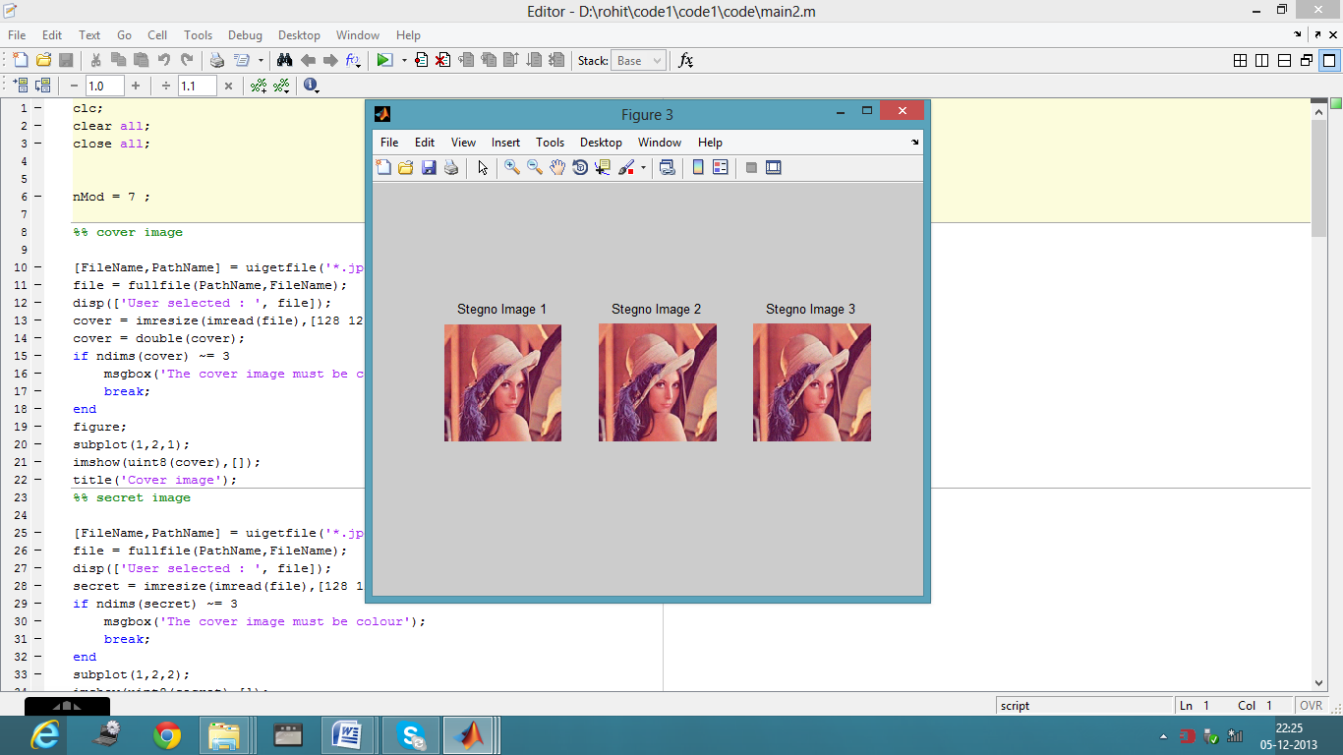
Fig B.5: STEGO IMAGE
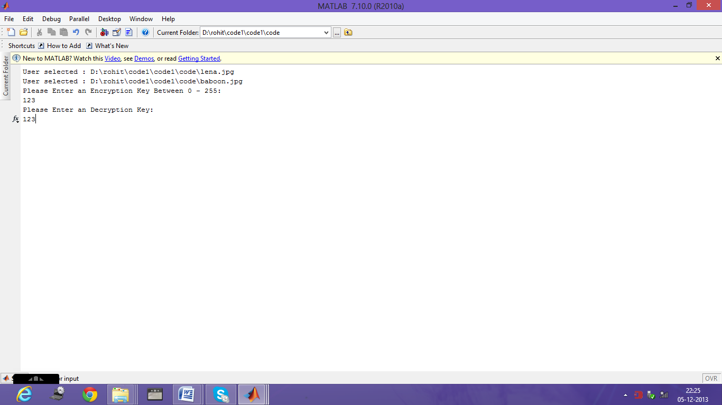
Fig B.6: INUPT DECRYPTION KEY
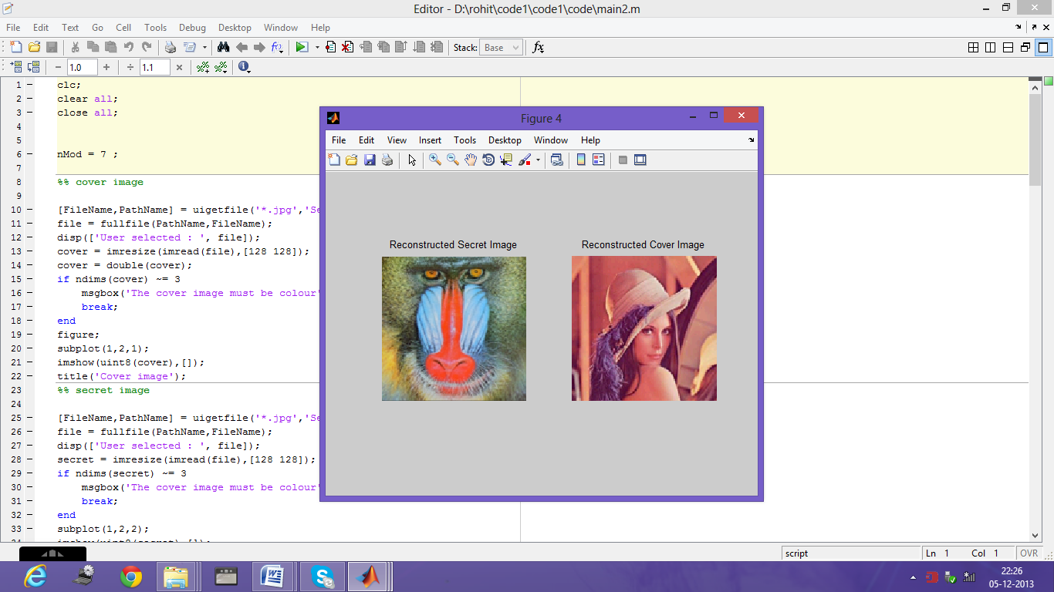
Fig B.7 : OUTPUT COVER & SECRET IMAGE
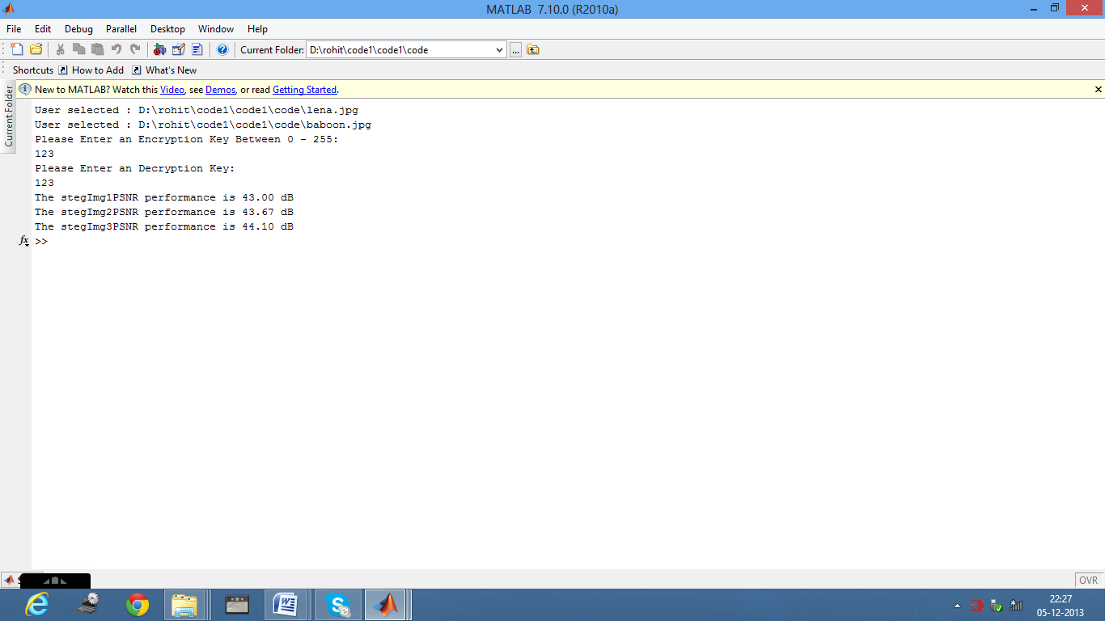
Fig B.: OUTPUT PSNR VALUES

REFERENCES
[1] Blakley G.R., l979. “Safeguarding cryptographic keys”. In: Proc. AFIPS National
Computer Conf., vol. 48, pp. 3l3–3l7.
[2] Beimel.A., Chor, B., l998. “Secret sharing with public reconstruction” IEEE
Trans.Inform. Theory 44 (5), l887– l896.
[3] Bender.W, D. Gruhl, N. Morimoto, & A.Lu, “Techniques for data hiding”, IBM
Systems Journal, 35, PP210-224, 2002
[4] Chang C.C., Hwang, R.J., l997. “Efficient cheater identification method for threshold
schemes” IEE Proc. – Comput. Digital Techn. l44 (l), 23– 27
[5] Hempstalk.A, “Hiding behind corners: Using edges in images for better
steganography,” Proceedings of the IEEE, Hamilton, New Zealand, 2006.
[6] Luo.L, Z. Chen, M. Chen, X. Zeng, Z. Xiong, “Reversible image watermarking using
interpolation technique,” IEEE Transactions on Information Forensics and Security, 5 ,1,
PP 187–193, 2010
[7] Naor.M, and A. Shamir, “Visual cryptography,” Advances in Cryptograhy:
EUROCRYPT’94, LNCS, vol. 950, pp. 1–12, 1995.
[8]Singh K.M, L. S. Singh, A. B. Singh, and K. S. Devi, “Hiding secret message in edges
of the image,” Proceedings of International Conference on Information and
Communication Technology, PP 238–241, 2007.
[9]Tian.J, “Reversible data embedding using a difference expansion.” IEEE Transactions
on Circuits and Systems for Video Technology, 13, 8, PP 890–896, 2003
[10]Wang R.Z., Su, C.H., 2006. “Secret image sharing with smaller shadow images
Pattern Recognition” Lett. 27(6),55l–555.
[11]Wang D., Zhang, L., Ma, N., Li, X., 2007. “Two secret sharing schemes based on
Boolean operations”. Pattern Recognition 40 (l0), 2776–2785
[12]. Wang C.M, Nan-I Wu, Chwei-Shyong Tsai,Min-Shiang Hwang, “ High quality
steganographic method with pixel-value differencing and modulus function,” Science
Direct The Journal of Systems and Software, 2007.
[13]Yang.C.H, C. Y. Weng, S. J. Wang, and H. M. Sun. “Adaptive data hiding in edge
areas of images with spatial LSB domain systems,” IEEE Transactions on Information
Forensics Security, 3, 3, PP 488–497, 2008.
[14] Yang, C.N., Chen, T.S., Yu, K.H., Wang, C.C., 2007. “Improvements of image
sharing with steganography and authentication” J. Syst. Software 80 (7), l070–l076.

